User Stories and Scenarios

Set 1

Note:

View Prototype here: <https://geoduqueza1939.github.io/SDOStoTomasBatangas/web/sergs/Prototype>

View Project Repository here: <https://github.com/geoDuqueza1939/SDOStoTomasBatangas/>

# Teacher A

A is a Teacher who is planning to file a request for loan. He logs into the Service Record Generation System and transacts a request for the Service Record document. The request status is then displayed as SENT. Later in the day, he checks the system for any notification. The request status is RECEIVED. After a few minutes, he refreshes the page and the request status is updated as CERTIFIED. He logouts of the system and closes the page. After a few days, he logs into the system again and sees that the request is APPROVED and clicks a link to view it for correctness. After verifying the contents, he clicks the print link to generate a printable version of the Service Record document and proceeds to print it. He then readies himself to go to the PLI for a loan.

# Administrative Officer B

B is an Administrative Officer who used to be assigned in encoding and certifying Service Record documents. She logs into the Service Record Generation System and receives a notification regarding a request for a service record document. She opens the request and, upon verifying that the requester is bona fide personnel, proceeds to review the automatically generated service record. She notices a discrepancy in the inclusive dates and reviews the 201 file of the said personnel. After determining that the “To” date of one of the entries is a typographic error, she EDITS the service record entry and directly corrects the error. After SAVING and ascertaining that there or no more errors, she proceeds to click CERTIFY and clicks YES when prompted by the system.

# Administrative Officer C

C is an Administrative Officer who used to approve Service Record documents. She logs into the Service Record Generation System and sees there are currently no CERTIFIED service record documents to be approved. She views the list of RECEIVED requests and finds a request with a link to generate a service record document. She looks at the desk of B, another Administrative Officer. Seeing that B is on duty, she informs her of the request. After some time, C receives a notification about a CERTIFIED service record document that needs to be approved. She proceeds to REVIEW the service record document and finds that one of the entries has a LEAVE OF ABSENCE W/O PAY that does not match the number of DATES. She checks on B and, seeing that she has suddenly been assigned a field assignment for the afternoon and is currently out of reach, proceeds to click on EDIT to add the missing dates after referring to the leave records attached to the 201. After verifying that there are no more errors left, she proceeds to SAVE the changes, CERTIFY, and APPROVE the Service Record.

# Staff D

D is an LSB staff assigned by City Hall to one of the schools as an Office Clerk. She requests a Service Record document using the Service Record Generation System. As she is an LSB staff, the system displays a message directing her to go to the Division Office for a MANUAL REQUEST and bring all necessary documents, such as previous Service Record documents, to assist the AO in encoding the requested Service Record. She submits the documents for encoding and waits for the Service Record to be released. After waiting for a few minutes, her new Service Record document is released.

# Person E

E is a random person who is bored in life. While surfing the web, he chances upon a link to the Service Record Generation System with a compromised user name and password of a former SDO staff who has transferred to another department. When he tried to use the user credentials, he successfully signs into the system. He then proceeds to REQUEST a Service Record document in behalf of the former SDO staff. As the SDO staff who owns the user credentials is no longer working within the SDO, the system displays a message instructing the user to proceed to the Division Office for a MANUAL REQUEST. As E is merely using another’s credentials, he gives up on the unauthorized access and closes his browser.

# Administrative Officer F

F is an Administrative Officer who has received a Manual Request for a Service Record document. He logs into the Service Record Generation System and clicks on Manual Request. He determines that the requester is no longer working under the SDO and sorts through the documents submitted by the requester to filter out any documents or Service Records that pertain to employment engaged in after the requester has left the SDO. He proceeds to generate a Service Record document that covers the period until the requester’s separation from the SDO. He counterchecks the generated Service Record document with the submitted documents, adds any entries that were missing, and corrects any entries with discrepancy. After updating the Service Record document, he allows the requester to preview the document and check for any discrepancies in any updated entries. After the Service Record is verified by both F and the requester, F then clicks on CERTIFY and informs an Approver about the Manual Request. Once the CERTIFIED Service Record document has been approved, F is then instructed by the Approver to print the Service Record document. Once the Service Record documents has been printed, he releases the document to the requestor and updates the request status to RELEASED IN-PERSON.

# Staff G

G is an Administrative Staff who wishes to only view her Service Record but not request a certified copy. She signs into the Service Record Generation System and clicks on the link VIEW MY SERVICE RECORD. Upon viewing her Service Record, she determines that one of the entries has a discrepancy. She proceeds to UPDATE the said entry, correcting or adding the necessary data. She clicks on SUBMIT UPDATES and an UPDATE REQUEST is displayed with options to either VIEW or CANCEL the UPDATE REQUEST. She, then, waits for an Administrative Officer to either approve the updates or invite her for an appointment.

# Teacher H

H is a Teacher who needs to submit copies of her Service Record for certain purposes. She visits the Service Record Generation System to view and print her Service Record without sending a Service Record request. She submits these printouts. Some are accepted immediately while others needed signatures. She visits the Division Office to have the copies of her Service Record authenticated/signed.

# Administrative Officer J

J is an Administrative Officer. A teacher drops by at the Division Office requesting for her printed Service Record to be signed. J logs into the Service Record Generation System and compares the requesting teacher’s printed and online Service Record document. After making sure that the Service Records match, he gets the printed Service Record signed and releases it back to the teacher.

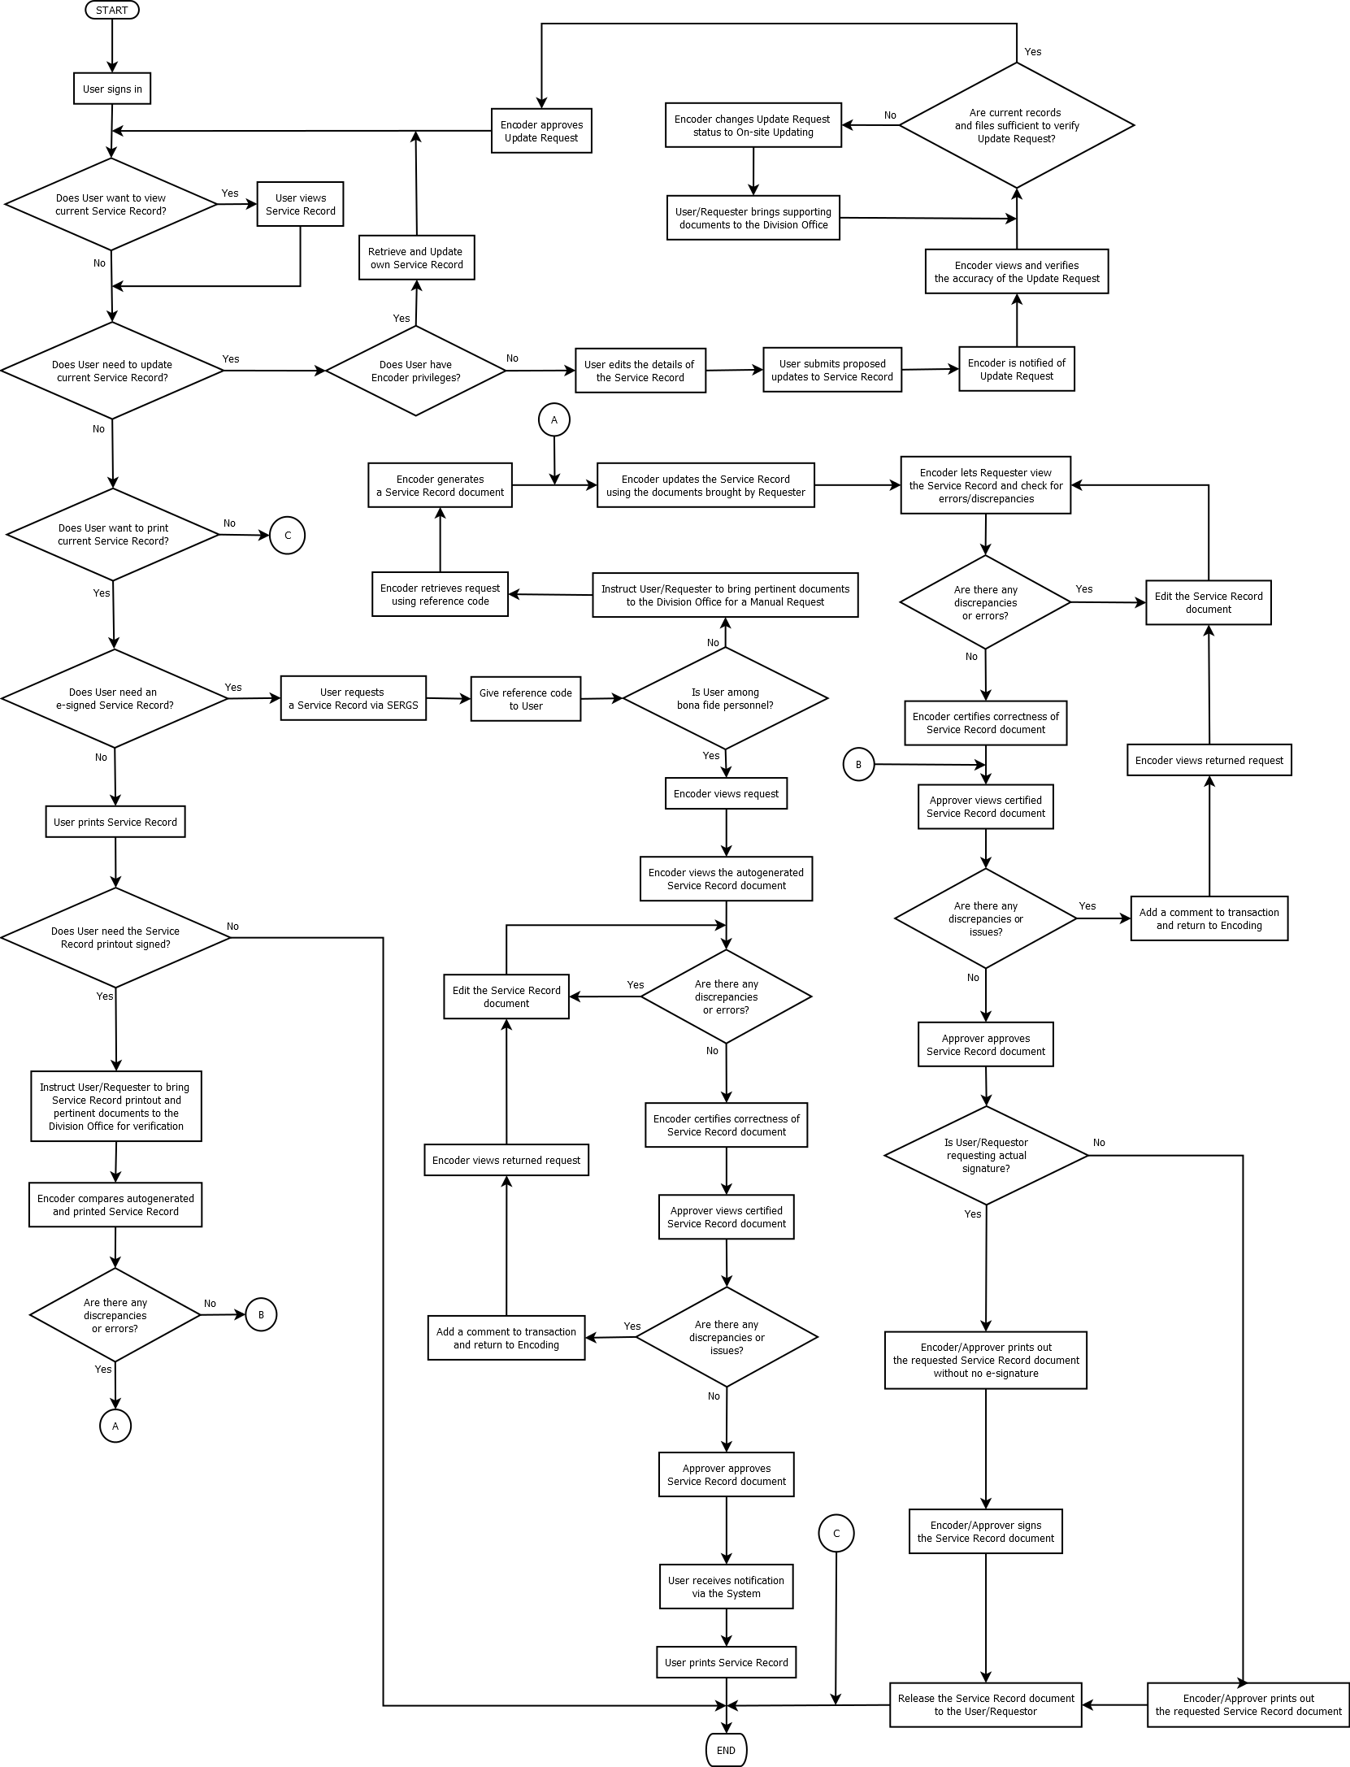Proposed Workflow